# **Randomized Algorithms**

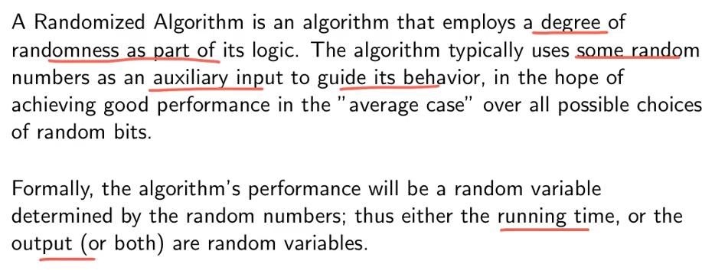

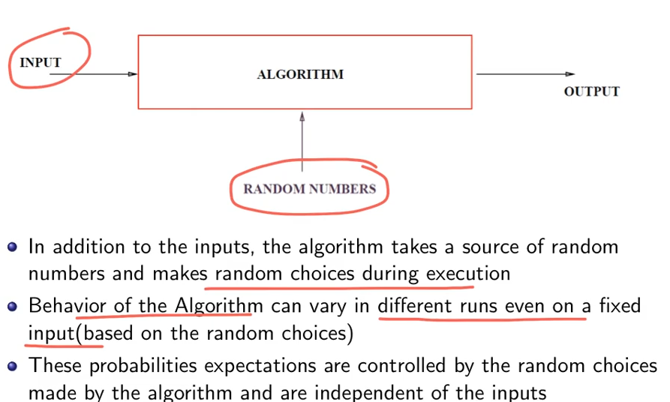

Major challenge in the Randomized Algorithm  
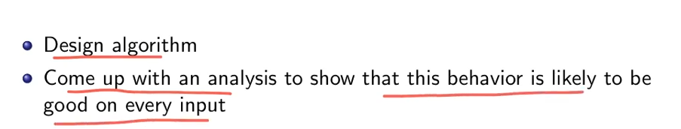

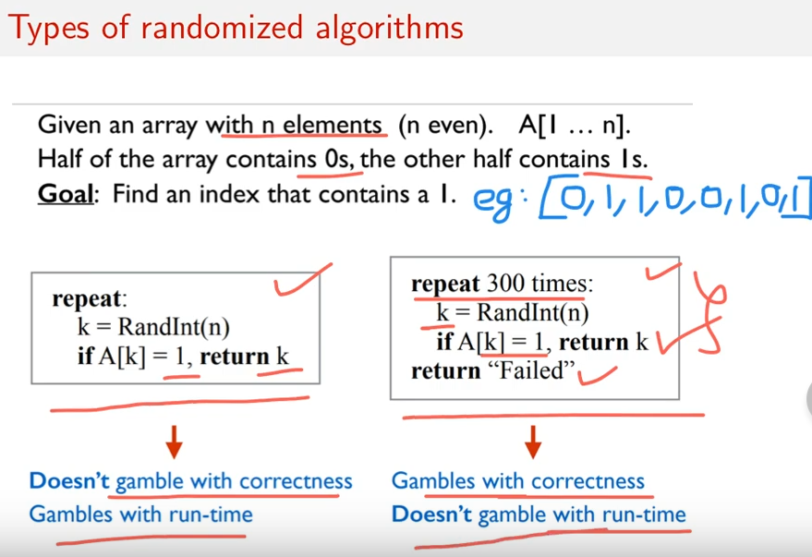

# **Intuition for Las Vegas Algorithm**

LHS 🡪 Until I get A[k]=1, this algorithms runs. Definitely we will get the exact answer.  
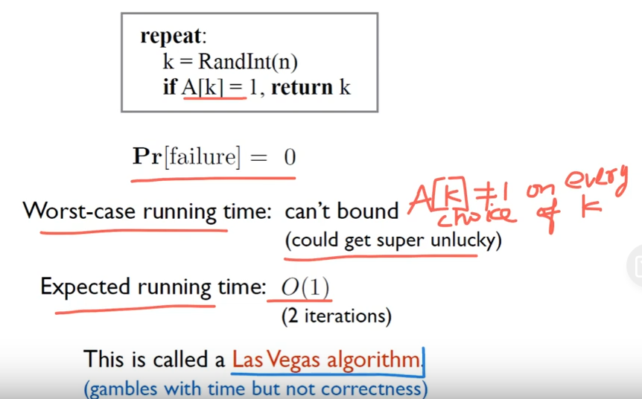

Time 🡪 Don’t know .  
Correctness 🡪 Answer will be right.

# **Intuition for Monte Carlo Algorithm**

RHS 🡪The algorithms runs only for 300 times. There is possibility that our algorithm will not give the exact answer.  
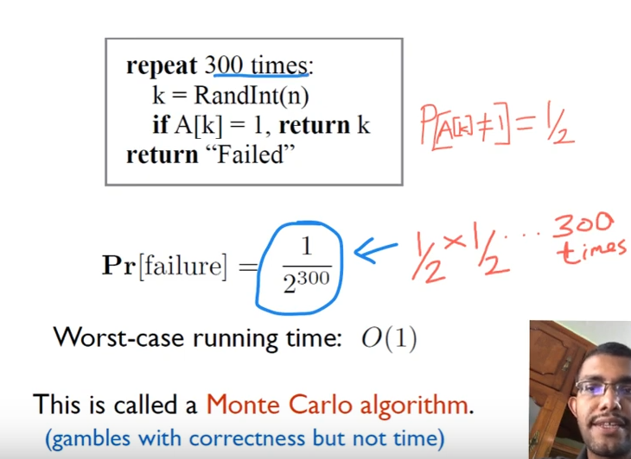

Time 🡪 Particular period.  
Correctness 🡪 The answer may/might not be right.

# **Quick Sort**

Quick sort works on the idea that the element is already in a sorted position, if all the elements to its left are smaller and all the elements to its right are larger

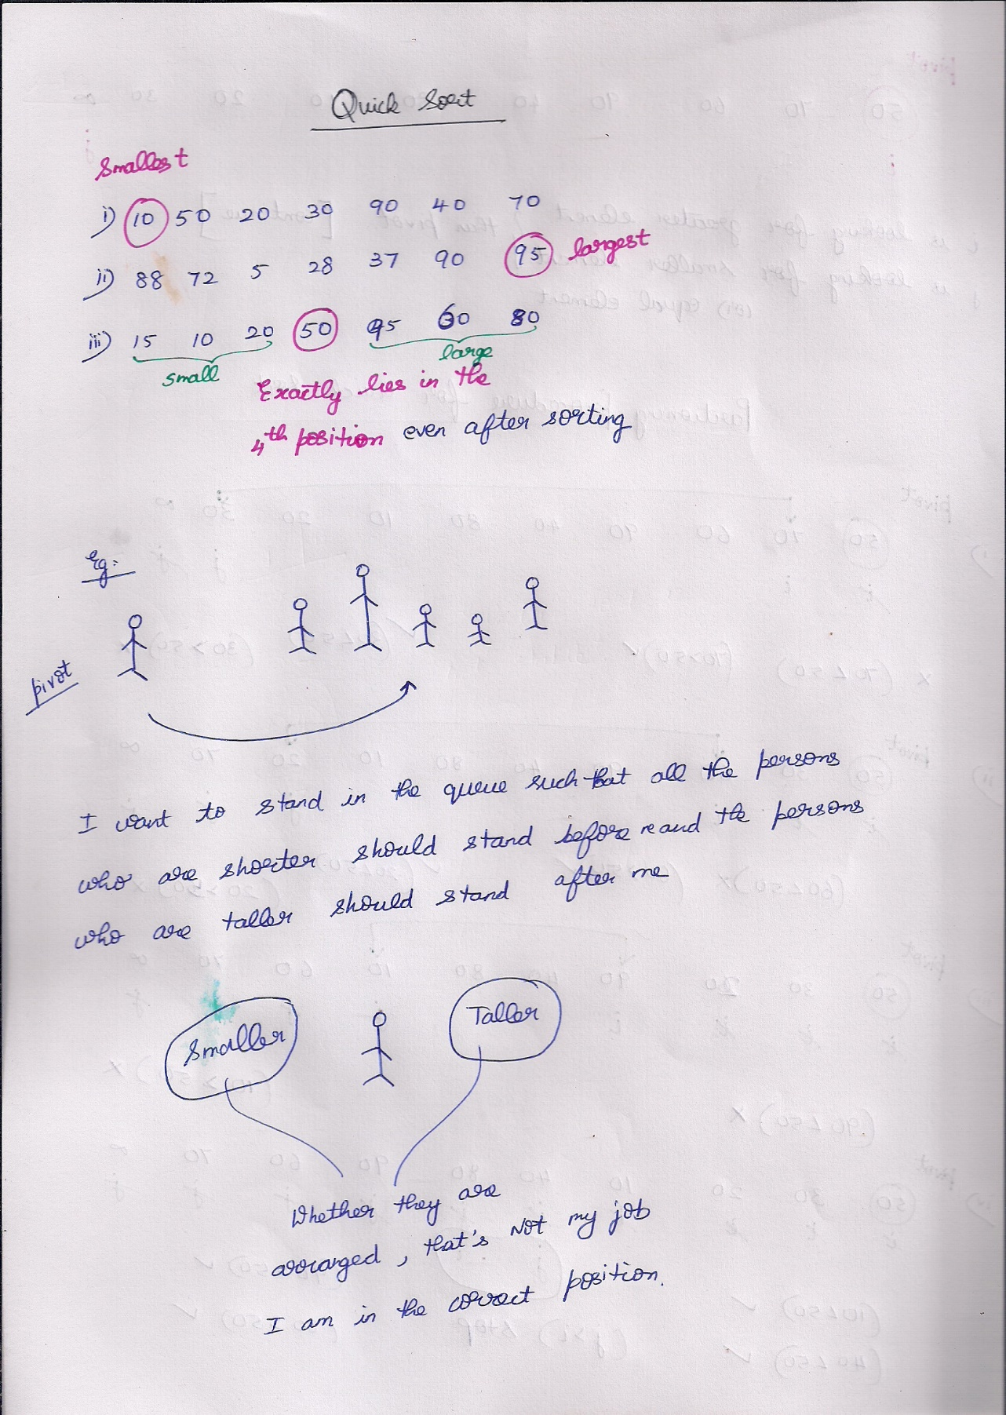

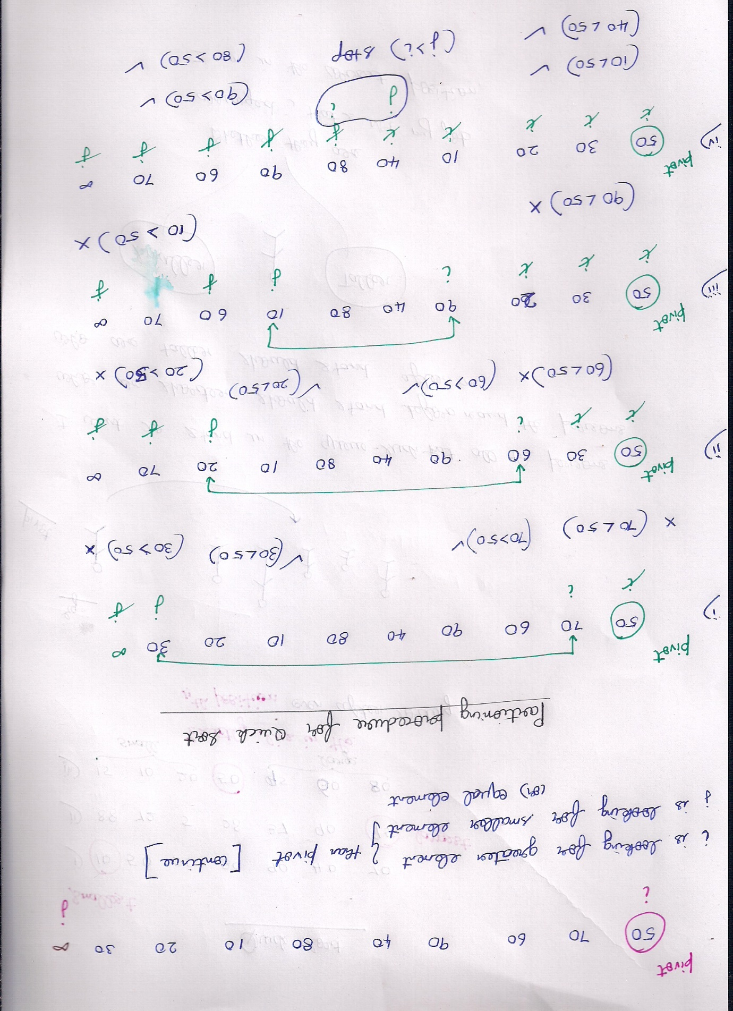  
if i is smaller than pivot 🡪 continue  
If j is larger than pivot 🡪 continue



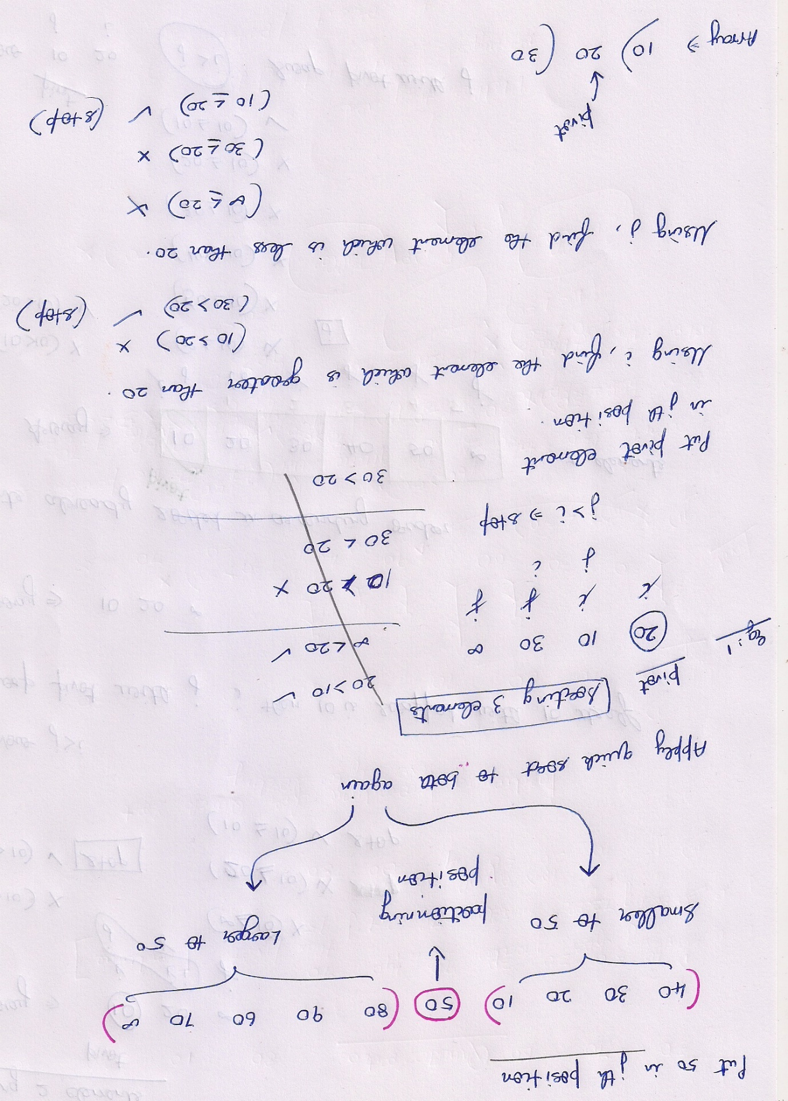

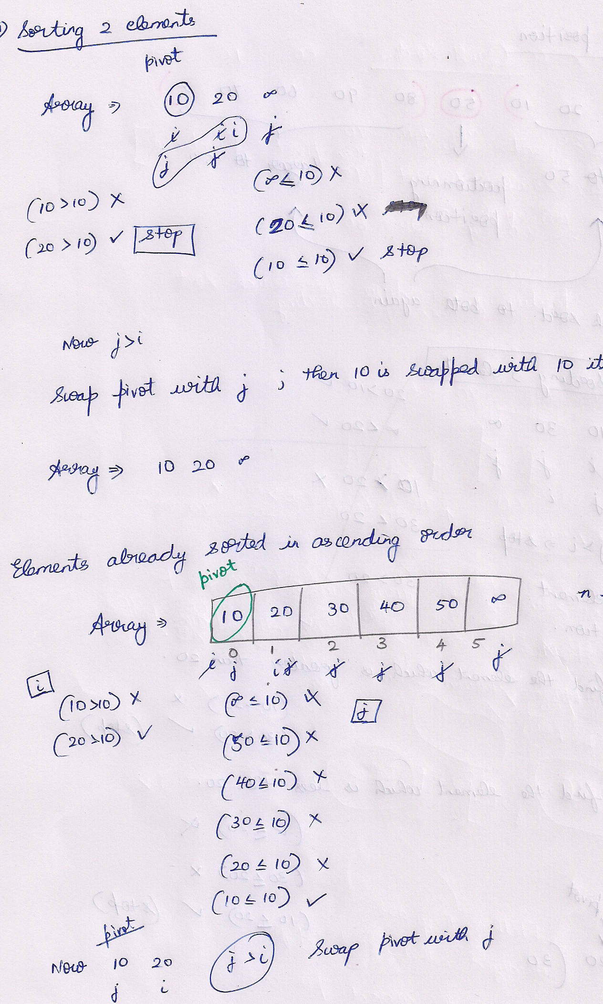

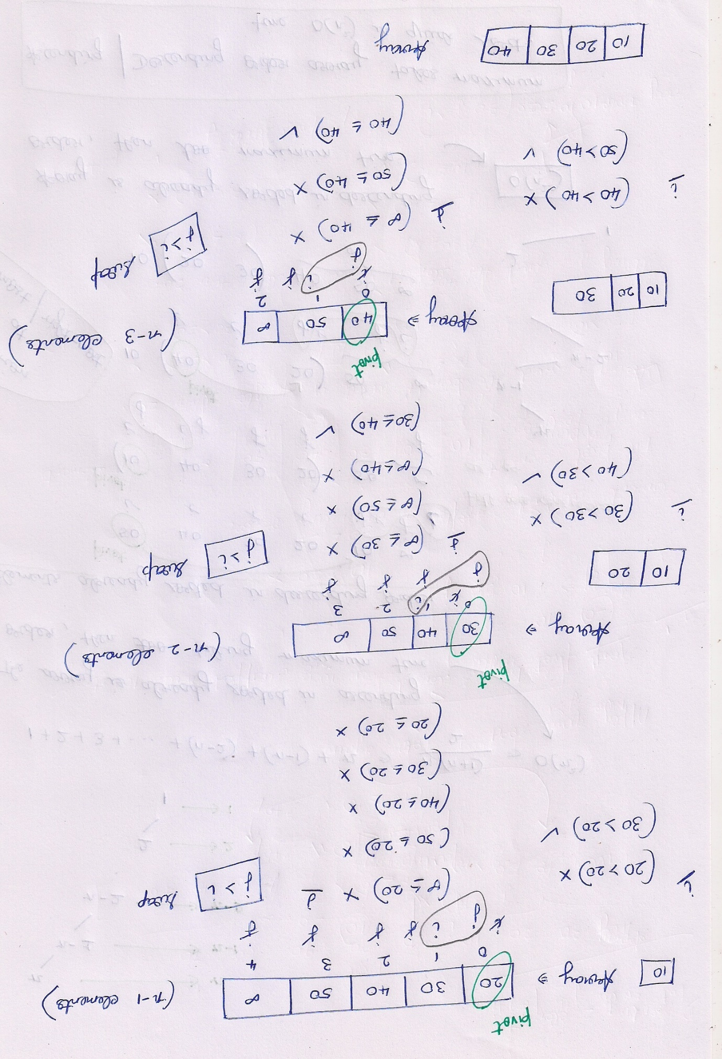

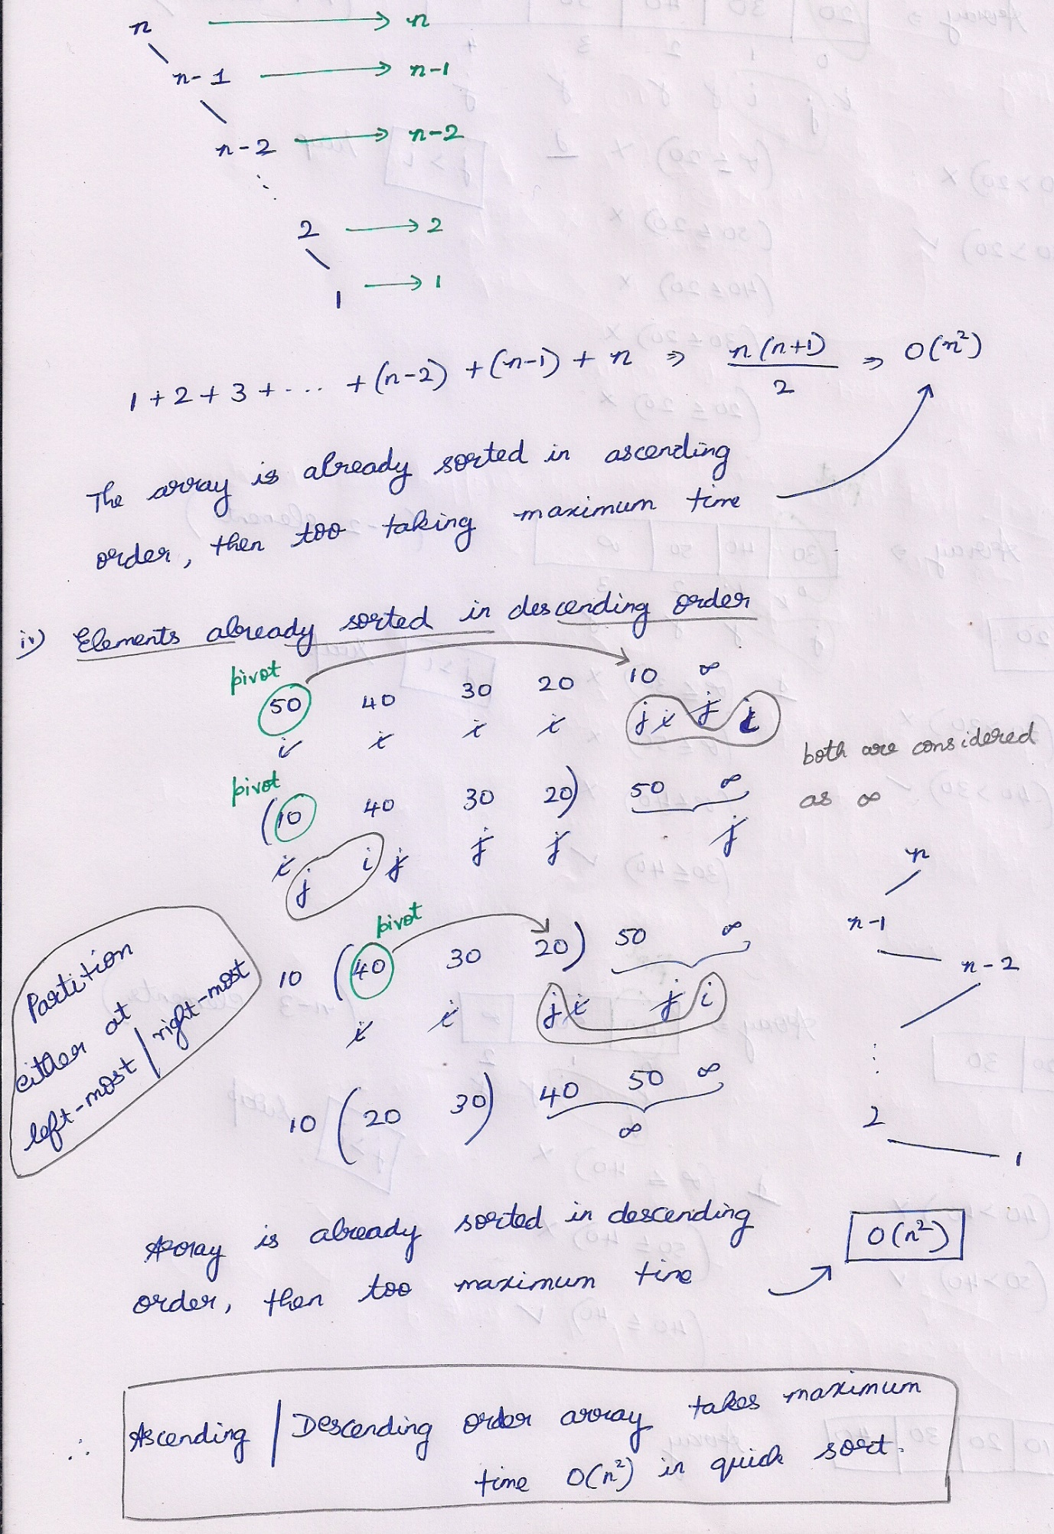

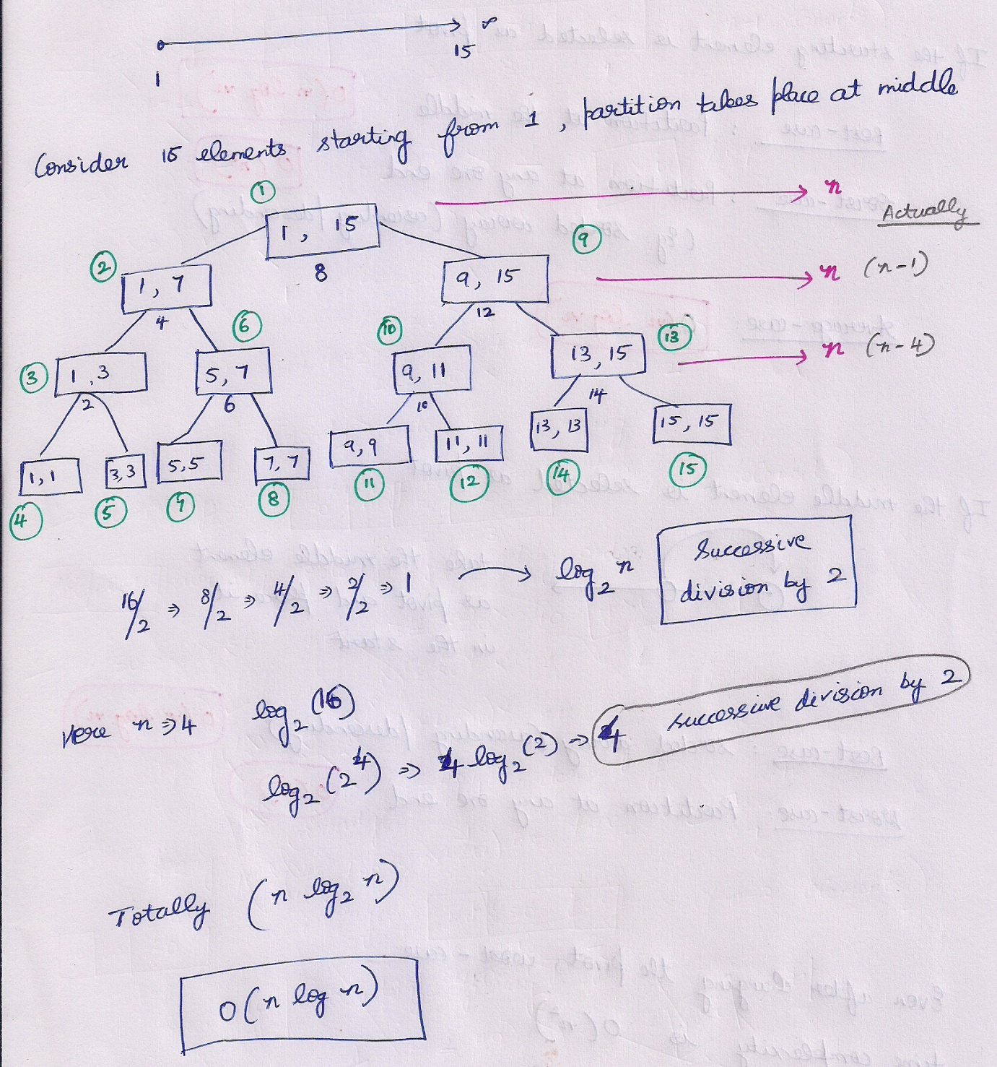

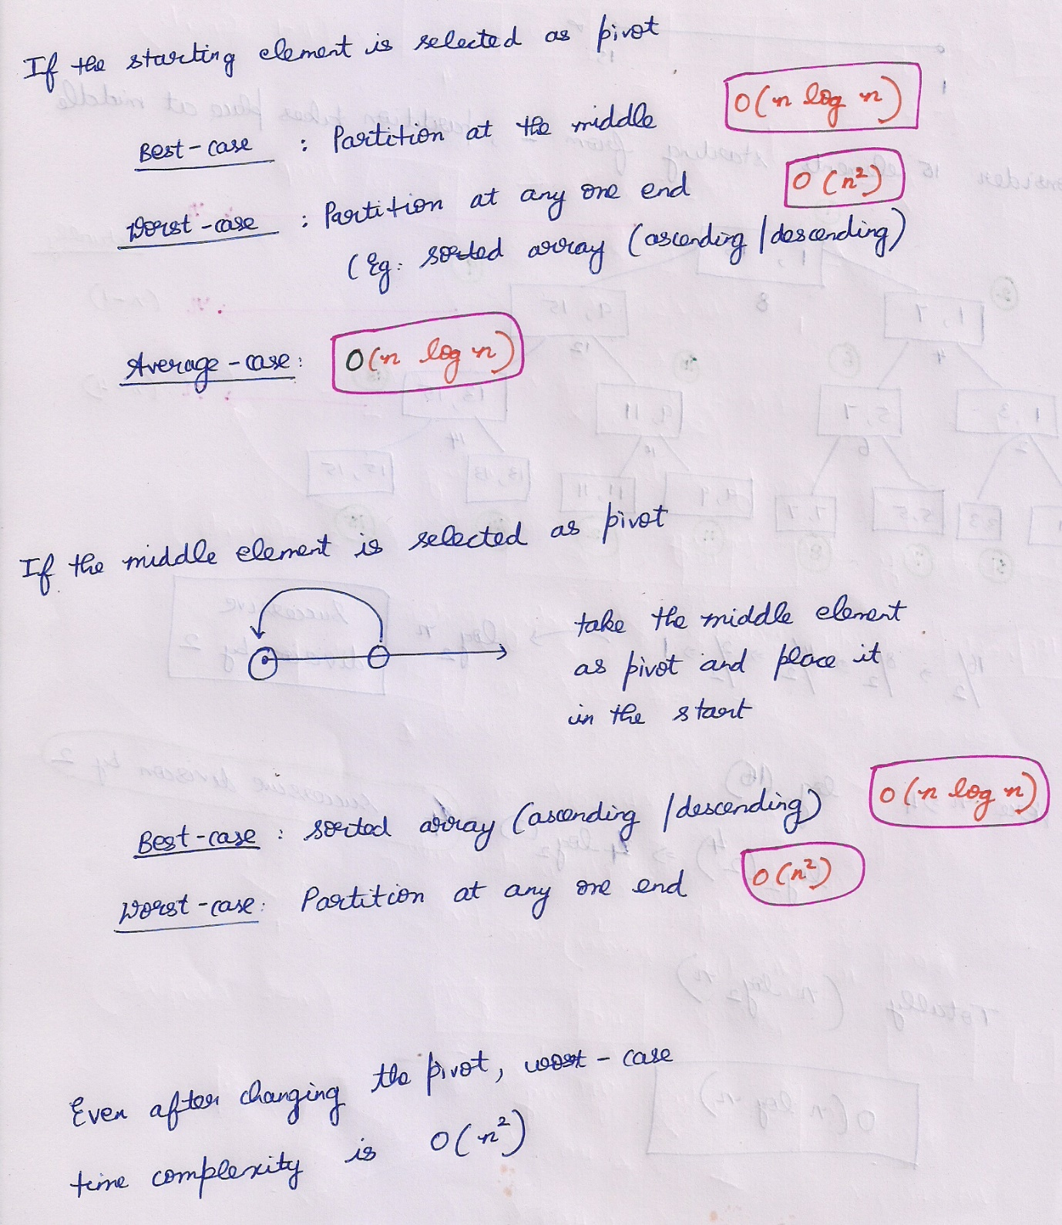

# **Las Vegas**

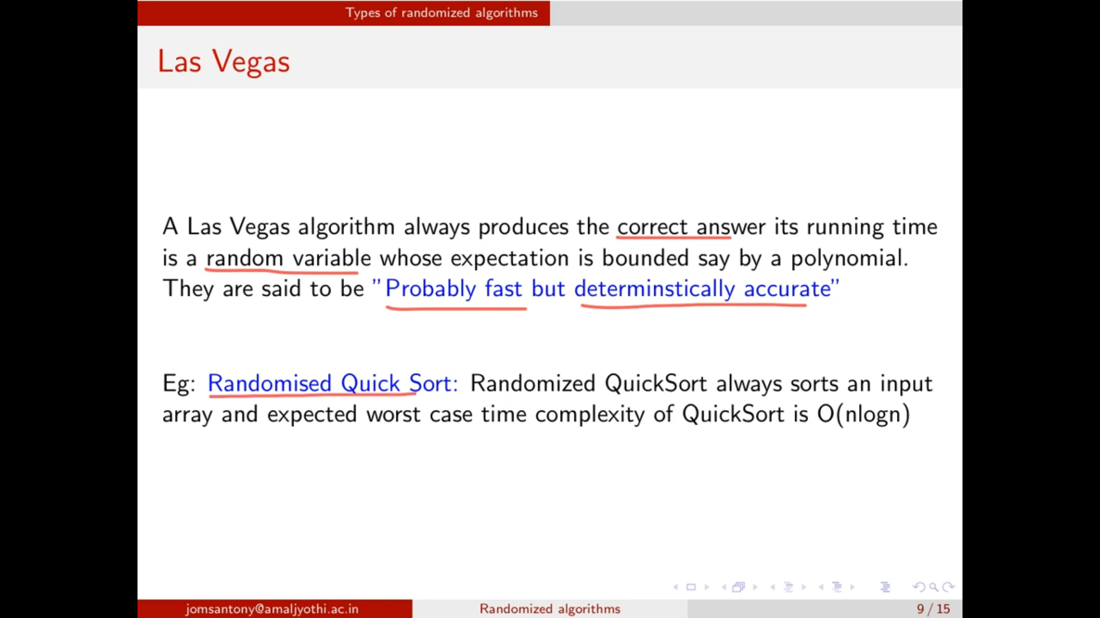

## **Randomized Quick Sort**

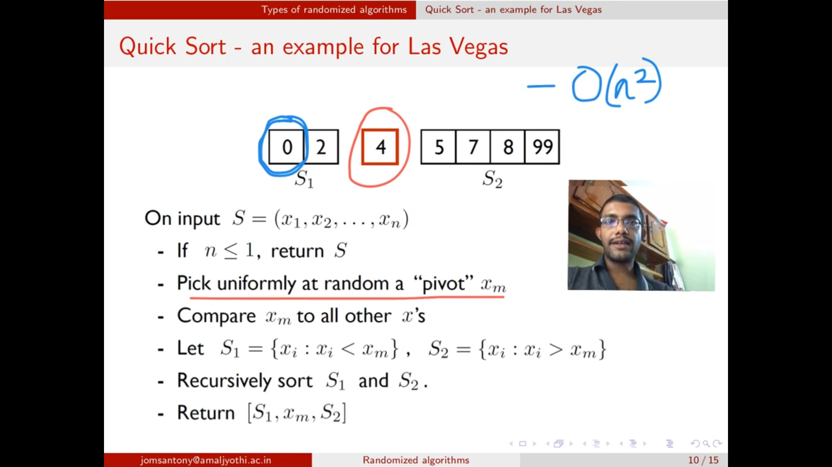

Pivot is selected randomly.

Normal quick sort 🡪 O(n^2)  
Randomized quick sort 🡪 O(n logn)

## **Searching Repeated elements**

i and j 🡪 random numbers must be generated within the array index. So only using   
**i = Random() mod n+1**   
**j = Random() mod n+1**

Indices should be different. And the elements matching.

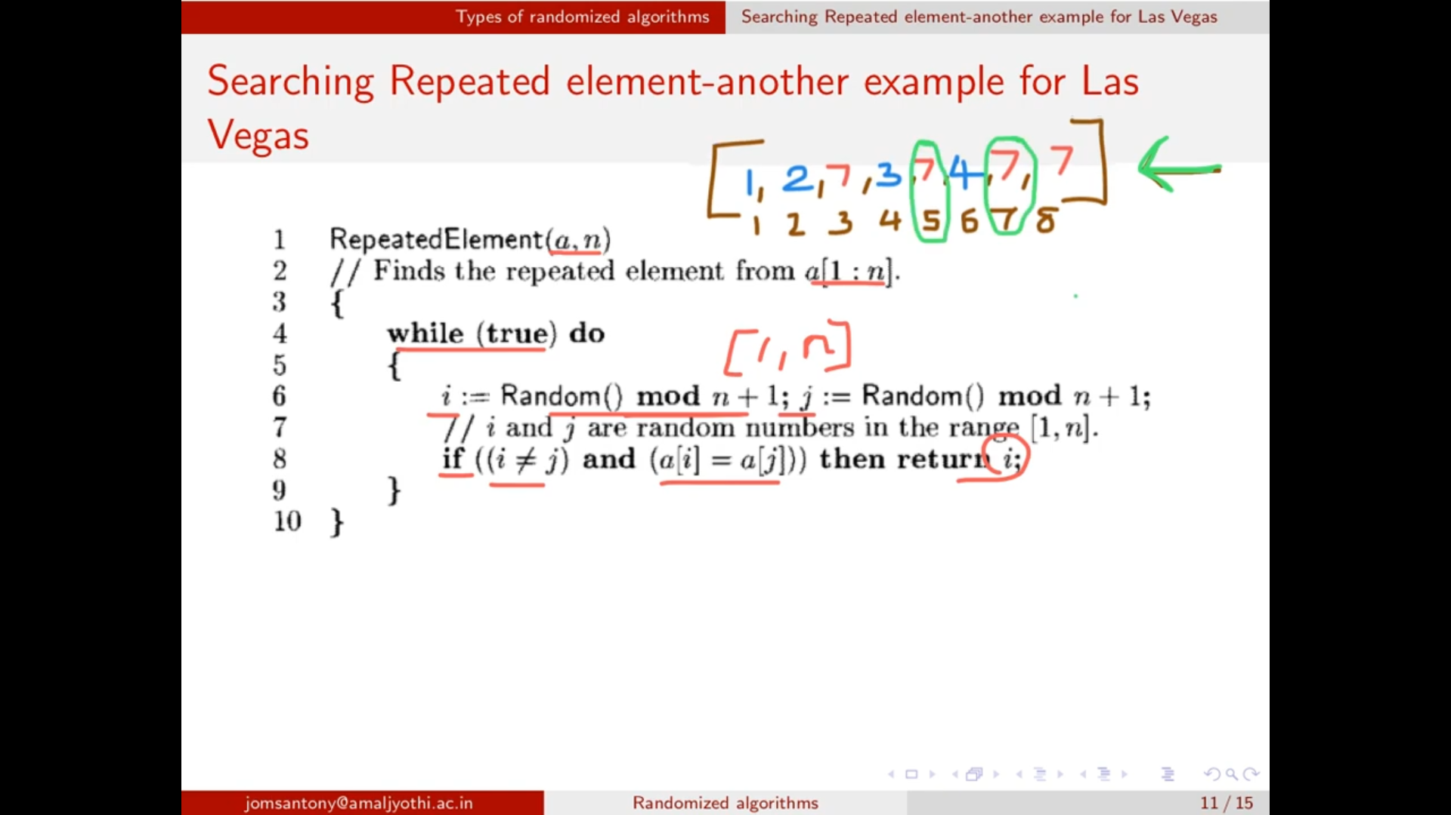

i = 5th index will be returned.

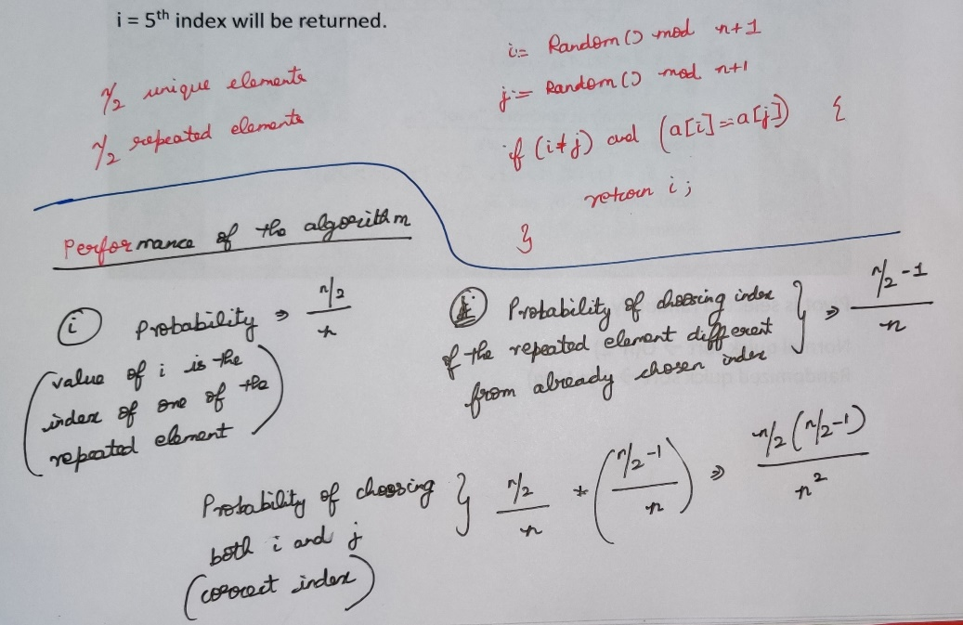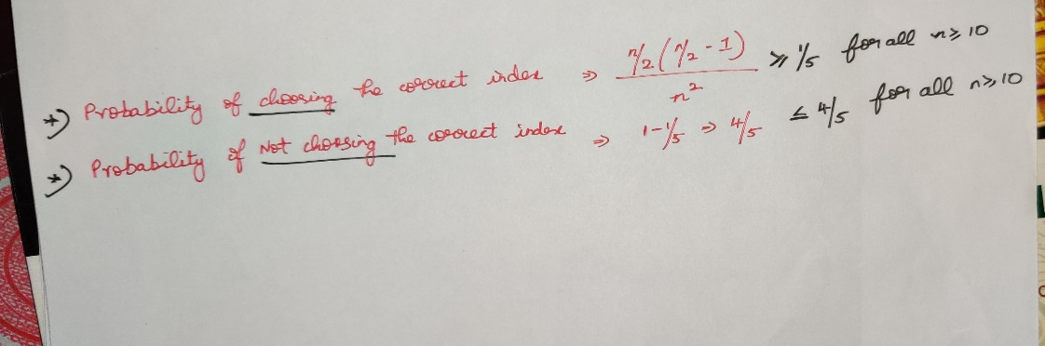

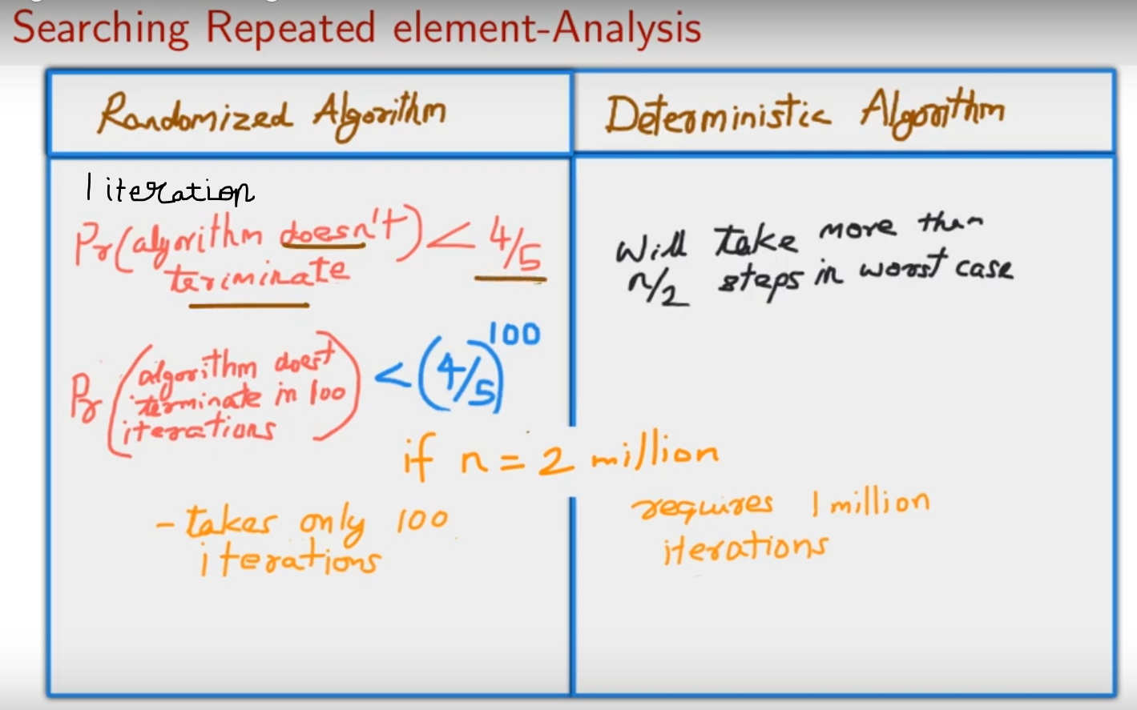

# **Monte Carlo Algorithm**

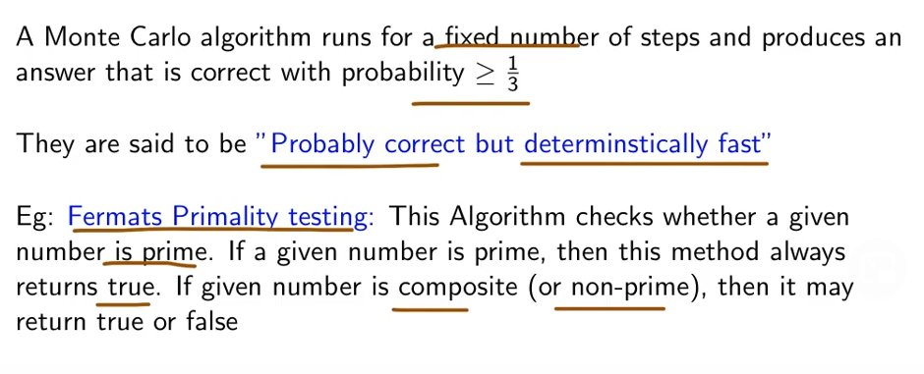

These algorithms are very use-full for the applications which doesn’t mind an occasional incorrect answer.

